PROJECT REPORT
Electronics Retail Sales
Performance Dashboard
Interactive analysis of revenue, profit, products, stores, cities and customers using Microsoft Power BI
Submitted By
Detail | Information
Name | Reethi
Student ID | E25FA037
Programme | BCom FinTech and Artificial Intelligence (FTAI), First Year
Institution | SDNB Vaishnav College for Women, Chennai
Tool Used | Microsoft Power BI Desktop
Dataset | Dataset 6 – Electronics Retail Sales

1. Introduction
Power BI is a business intelligence and data visualisation tool developed by Microsoft. It converts raw data into meaningful information through interactive reports, dashboards, charts and tables.
For this project, an Electronics Retail Sales dataset was used to build an interactive report in Microsoft Power BI. The dataset describes the sales of an electronics retailer that sells through an online store and through physical stores in several Indian cities. It covers product categories such as mobile phones, laptops, televisions, home appliances, audio, wearables and accessories, and contains revenue, profit, orders and quantity.
The main purpose of the dashboard is to analyse the revenue and profit performance of the business across products, store types, stores, cities, states and months. KPI cards, column and bar charts, a donut chart, a treemap, a line chart and a table with sparklines are used to present the information, and slicers for product category, year, store type and customer segment allow the data to be filtered. A drill-down view and a store type tooltip page provide extra detail.

2. Objectives of the Project
- To build an interactive retail sales dashboard using Microsoft Power BI.
- To track total revenue, total profit, total orders, total quantity and average order value.
- To compare revenue across product categories and drill down to individual product types.
- To compare revenue across stores, cities and states.
- To understand the contribution of each store type (Online, Urban, Flagship, Mall, Suburban).
- To analyse profit by product category.
- To study how revenue changes from month to month.
- To provide filtering by product category, year, store type and customer segment.
- To provide a tooltip page showing key figures when the user hovers over a store type.

3. Dataset Description
The dataset contains one record per sale, with details of the product, the store, the customer segment and the date. Product, store and date information is organised into related tables in the Power BI model so that any of them can be used to filter the sales data.
The major fields used in the dashboard are:
Field | Description
Product Category | The main product group: Mobile Phones, Laptops, Televisions, Home Appliances, Audio, Wearables or Accessories
Product (sub-category) | The product type within a category, such as Mid-Range Smartphones, Budget Laptops or Air Conditioners
Store | The store where the sale was made, including the Online Store and mall stores in several cities
Store Type | The type of store: Online, Urban, Flagship, Mall or Suburban
City / state_name | The city and state of the store; online sales are grouped as “Online / National”
Customer Segment | The type of customer, such as Premium, Regular or Occasional
full_date / Year / Month | Used for year-wise and month-wise analysis (2024 to 2026)
Revenue | The total sales value, in ₹
Profit | The profit earned on the sales, in ₹
Orders / Quantity | The number of orders and the number of units sold

4. Data Preparation
Before creating the dashboard, the data was organised in Power BI so that the different tables and fields could be used for analysis. The main preparation activities were:
- Importing the retail sales dataset into Power BI Desktop.
- Organising the data into product, store, customer and date information and relating them to the sales data.
- Checking the product category, product, store, city, state, store type and customer segment fields.
- Preparing date information for year and month-based analysis.
- Formatting revenue and profit in ₹ and setting suitable display units (million and billion).
- Grouping online sales as “Online / National” so they are not tied to a single state.
- Creating DAX measures for revenue, profit, orders, quantity and average order value.
- Setting up drill-down on the product category chart and a separate tooltip page for store types.
Proper data preparation is important because the accuracy of the dashboard depends on correctly organised data and calculations. During this stage it was also noticed that some text values differ only in capitalisation (for example “Urban” and “urban”, and “PREMIUM” and “Premium”); these should be standardised.

5. DAX Measures Used
Several DAX measures were created and used in the dashboard to calculate important business indicators.
Measure | What it calculates | Value on dashboard
Total Revenue | Total sales value | ₹ 4.71bn
Total Profit | Total profit earned | ₹ 979.89M
Total Orders | Number of orders | 15K
Total Quantity | Total units sold | 112K
Average Order Value | Revenue divided by the number of orders | ₹ 313.80K

The state-wise table on the dashboard was used to check the measures: its totals of ₹4,70,70,20,747.02 in revenue and ₹97,98,91,147.02 in profit match the 4.71bn and 979.89M KPI cards. The average order value (₹313.80K) also agrees with revenue divided by orders (4.71bn ÷ about 15,000).

6. Dashboard
The dashboard is a single interactive page with KPI cards and slicers across the top, followed by two rows of visuals. Supporting views include a drill-down version of the product category chart, a KPI card view, and a store type tooltip page.
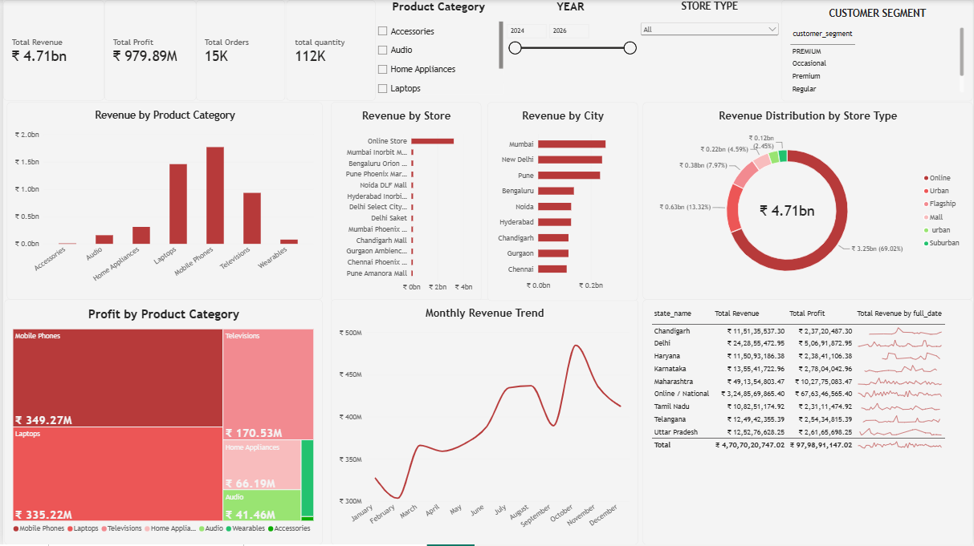
Figure 1: Electronics Retail Sales dashboard
The dashboard lets the user compare product categories, stores, cities and store types, follow revenue through the months, and review state-level revenue and profit. All visuals respond to the slicers, so a single category, year, store type or customer segment can be examined in isolation.

7. Dashboard Components
Each visual provides a different view of the business performance.

→ KPI Cards
Five key indicators are shown at the top of the dashboard: Total Revenue (₹4.71bn), Total Profit (₹979.89M), Total Orders (15K), Total Quantity (112K) and Average Order Value (₹313.80K).
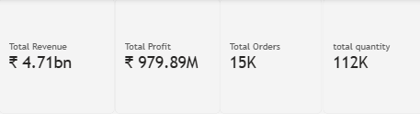
Figure 2: KPI cards on the dashboard
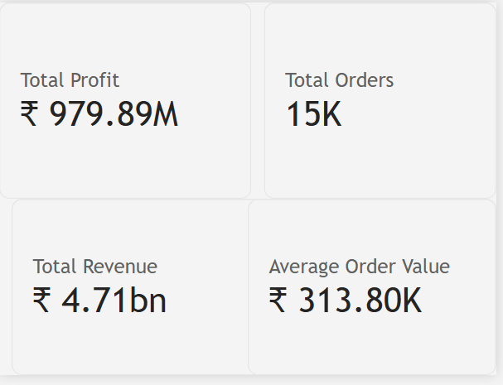
Figure 3: KPI card view: profit, orders, revenue and average order value
Purpose
- To give the most important figures at a glance.
- To summarise sales scale, profitability and order size.
- To give context for every other visual.

→ Revenue by Product Category
A Column Chart compares revenue across the seven product categories. Mobile Phones lead with about ₹1.77bn, followed by Laptops (about ₹1.47bn) and Televisions (about ₹0.93bn). Home Appliances (about ₹0.32bn), Audio, Wearables and Accessories contribute much less. Mobile Phones, Laptops and Televisions together make up nearly 90% of revenue.
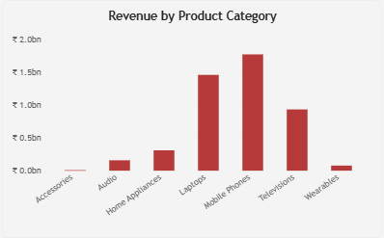
Figure 4: Revenue by Product Category
Purpose
- To compare revenue across categories.
- To identify the main revenue-driving categories.
- To support drilling down to product types.

→ Revenue by Product Category (Drill Down)
The drill-down view expands each category into its product types. The highest-revenue products are Mid-Range Smartphones (about ₹0.6bn), Mid-Range Laptops (about ₹0.5bn) and Mid-Range TVs (about ₹0.3bn), followed by Budget Smartphones (about ₹0.26bn), Budget Laptops and Gaming Laptops (about ₹0.2bn each). Accessories such as cables, chargers, adapters and laptop bags contribute very little. The mid-range tier therefore drives the largest share of revenue.
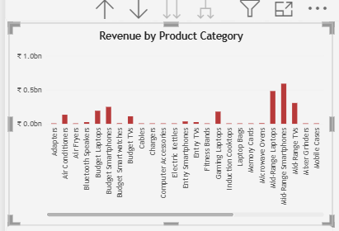
Figure 5: Revenue by product type (drill-down)
Purpose
- To see which individual product types earn the most revenue.
- To compare budget, entry and mid-range tiers.
- To identify low-revenue products for review.

→ Revenue by Store
A Bar Chart compares revenue across stores. The Online Store is far ahead of every other store (about ₹3.25bn, shown on a 0–4bn scale), while each physical store, such as Mumbai Inorbit Mall, Bengaluru Orion Mall and Pune Phoenix Marketcity, appears as a very small bar by comparison.
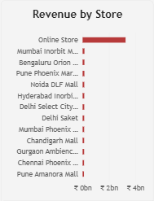
Figure 6: Revenue by Store
Purpose
- To compare store-level revenue.
- To show the dominance of the online channel.

→ Revenue by City
A Bar Chart shows revenue from physical stores by city. Mumbai is the largest (about ₹0.26bn), followed by New Delhi (about ₹0.24bn) and Pune (about ₹0.23bn). Bengaluru, Noida, Hyderabad, Chandigarh, Gurgaon and Chennai each contribute roughly ₹0.1–0.13bn.
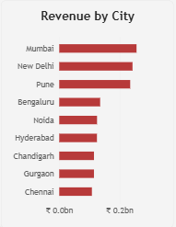
Figure 7: Revenue by City
Purpose
- To compare physical-store revenue across cities.
- To identify the strongest city markets.

→ Revenue Distribution by Store Type
A Donut Chart shows the contribution of each store type to the ₹4.71bn total. Online accounts for ₹3.25bn (69.02%), Urban stores ₹0.63bn (13.32%), Flagship stores ₹0.38bn (7.97%) and Mall stores ₹0.22bn (4.59%). The remaining slices (lowercase “urban” and Suburban) together make up about 5%, with the smaller labelled slice at ₹0.12bn (2.45%).
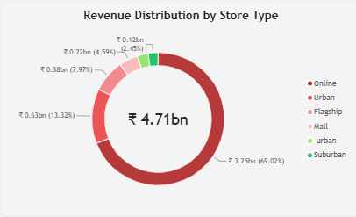
Figure 8: Revenue Distribution by Store Type
Purpose
- To show each store type’s share of revenue.
- To compare online and physical channels.
- To support the store type tooltip.

→ Profit by Product Category
A Treemap shows profit by category, with larger rectangles for higher profit. Mobile Phones earn ₹349.27M and Laptops ₹335.22M, followed by Televisions (₹170.53M), Home Appliances (₹66.19M) and Audio (₹41.46M). Wearables and Accessories are small slivers.
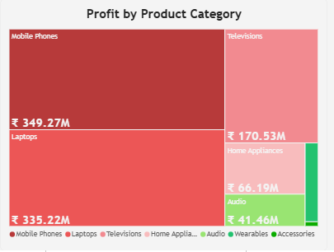
Figure 9: Profit by Product Category
Purpose
- To compare profit across categories at a glance.
- To see which categories contribute most to profit.

→ Monthly Revenue Trend
A Line Chart shows revenue for each month. Revenue is lowest in February (about ₹305M), rises through spring and summer to about ₹430M in July–August, dips in September, and then reaches its highest point in October (about ₹485M) before easing to about ₹410M in December.
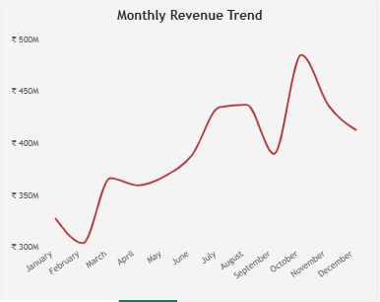
Figure 10: Monthly Revenue Trend
Purpose
- To identify seasonal patterns.
- To spot peak and low months for planning.

→ State-wise Revenue and Profit Table
A Table visual lists revenue and profit for each state, with a small sparkline showing the revenue trend over time. Online sales appear as “Online / National” (₹3,24,85,69,865.40), followed by Maharashtra (₹49,13,54,803.47) and Delhi (₹24,28,55,472.95). The totals are ₹4,70,70,20,747.02 in revenue and ₹97,98,91,147.02 in profit.
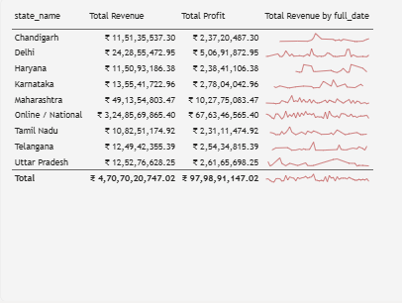
Figure 11: State-wise revenue, profit and trend
Purpose
- To show exact revenue and profit by state.
- To see short-term trends with sparklines.
- To validate the measures against the KPI cards.

→ Store Type Tooltip Page
When the user hovers over a store type in the donut chart, a tooltip page appears. For the Online store type it shows Total Profit ₹676.35M, Total Orders 11K, Total Revenue ₹3.25bn and Average Order Value ₹304.17K.
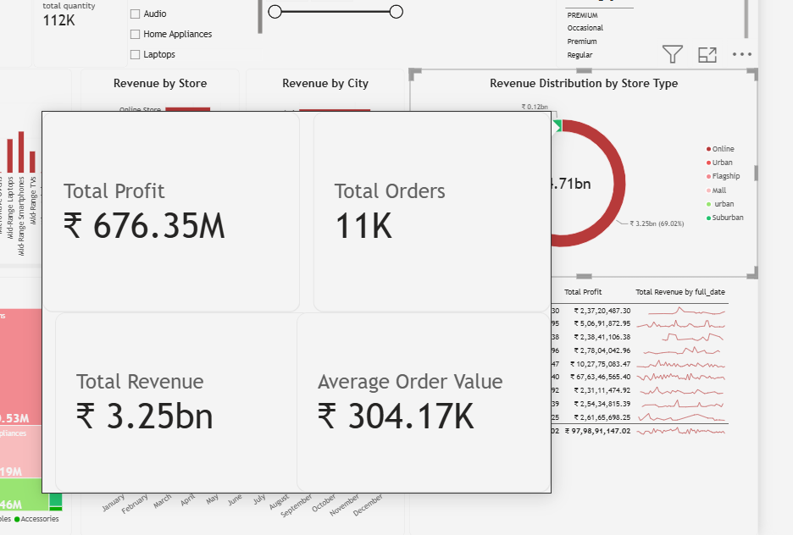
Figure 12: Store Type Tooltip shown on hover over the Online slice
Purpose
- To give extra detail on hover without crowding the dashboard.
- To compare a store type with the overall totals.

8. Slicers Used
Four slicers are included at the top of the dashboard:
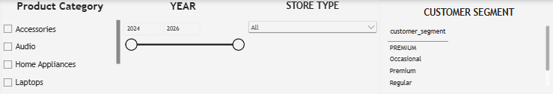
Figure 13: Product Category, Year, Store Type and Customer Segment slicers
1. Product Category – Checkboxes for Accessories, Audio, Home Appliances, Laptops and the other categories.
2. Year – A range slicer (2024 to 2026) that filters the dashboard by year.
3. Store Type – A drop-down for selecting Online, Urban, Flagship, Mall or Suburban stores.
4. Customer Segment – A list of customer segments such as Premium, Regular and Occasional.
When a selection is made, the related charts and KPI cards update. For example, the user can choose Laptops and the Flagship store type to study how laptops perform in flagship stores.

9. Key Findings
The major observations from the dashboard are summarised below. The state-wise table gives the exact revenue and profit figures.
State / Channel | Revenue | Profit | Margin | Share
Online / National | ₹ 3248.57M | ₹ 676.35M | 20.8% | 69.0%
Maharashtra | ₹ 491.35M | ₹ 102.78M | 20.9% | 10.4%
Delhi | ₹ 242.86M | ₹ 50.69M | 20.9% | 5.2%
Karnataka | ₹ 135.54M | ₹ 27.80M | 20.5% | 2.9%
Uttar Pradesh | ₹ 125.28M | ₹ 26.17M | 20.9% | 2.7%
Telangana | ₹ 124.94M | ₹ 25.43M | 20.4% | 2.7%
Chandigarh | ₹ 115.14M | ₹ 23.72M | 20.6% | 2.4%
Haryana | ₹ 115.09M | ₹ 23.84M | 20.7% | 2.4%
Tamil Nadu | ₹ 108.25M | ₹ 23.11M | 21.3% | 2.3%
Total | ₹ 4707.02M | ₹ 979.89M | 20.8% | 100.0%

- Overall performance: Revenue of ₹4.71bn and profit of ₹979.89M give a profit margin of about 20.8% from about 15,000 orders and 112,000 units.
- Online dominates: The Online store contributes about 69% of revenue and about 69% of profit, with 11K of the 15K orders. Its average order value (₹304.17K) is slightly below the overall ₹313.80K.
- Physical stores: Physical stores together earn about ₹1.46bn. Their average order value is roughly ₹338K, higher than online, so physical stores sell bigger baskets with fewer orders.
- Top markets: Maharashtra (Mumbai and Pune) and Delhi are the strongest physical markets; Maharashtra alone gives about a third of all physical-store revenue.
- Category concentration: Mobile Phones, Laptops and Televisions give nearly 90% of revenue and about 90% of profit; Wearables and Accessories are minor.
- Profitability by category: Estimated margins are highest for Audio (about 24%) and Laptops (about 23%), and lowest for Televisions (about 18%). Mobile Phones are about 20%.
- Uniform margin: The margin is about 20–21% in every state and channel, which suggests profit follows a steady percentage of revenue.
- Mid-range products lead: Mid-Range Smartphones, Laptops and TVs together bring in roughly ₹1.4bn, about 30% of revenue.
- Seasonality: Revenue peaks in October (about ₹485M, likely the festive season), with a smaller high in July–August and the lowest month in February.
- Order size: About 7.5 units per order and ₹42K per unit suggest many orders are for several items or bulk purchases.
Points to verify
- Category and tier margins are estimated from chart readings; exact margins should be calculated from the data.
- “Urban” and “urban”, and “PREMIUM” and “Premium”, appear as separate values and should be merged to avoid split totals.
- The monthly trend combines all selected years; selecting a single year in the slicer will show year-specific seasonality.
Note: values read from chart axes are approximate; exact figures are those shown in the KPI cards, data labels and tables.

10. Importance of the Dashboard
- Easy Data Understanding – Thousands of orders become easy to understand through KPI cards and a few charts.
- Quick Decision-Making – Revenue, profit, orders and average order value are visible at a glance.
- Product Strategy – Category, drill-down and treemap views show which products to stock and promote.
- Channel Analysis – The store type chart and tooltip compare online and physical channels.
- Regional Planning – The city and state views show which markets are strongest.
- Seasonal Planning – The monthly trend helps plan inventory and campaigns for peak months such as October.
- Customer Insight – The customer segment slicer helps study different buyer groups.
- Interactive Analysis – Slicers, drill-down and tooltips allow detailed exploration.

11. Conclusion
The Electronics Retail Sales Dashboard demonstrates how Microsoft Power BI can turn retail data into an interactive and meaningful report. The project helped in understanding data preparation, DAX measures, KPI cards, column, bar, donut, treemap and line charts, tables with sparklines, slicers, drill-down and tooltip pages.
The dashboard shows that the business earned ₹4.71bn in revenue and ₹979.89M in profit, that about 69% of revenue comes from the online store, that mobile phones, laptops and televisions drive most of the sales, and that revenue peaks in October. Overall, the project shows how Power BI can support effective retail sales analysis and decision-making.

12. References
- Microsoft Power BI Desktop
- Electronics retail sales dataset (Dataset 6)
- Microsoft Power BI Documentation
- Microsoft DAX Documentation

